#include <stdio.h>

#include <stdlib.h>

struct stack {

int data;

struct stack* next;

};

void initStack(struct stack** s) { *s = NULL; }

int isEmpty(struct stack* s)

{

if (s == NULL)

return 1;

return 0;

}

void push(struct stack** s, int x)

{

struct stack* p = (struct stack*)malloc(sizeof(*p));

if (p == NULL) {

fprintf(stderr, "Memory allocation failed.\n");

return;

}

p->data = x;

p->next = *s;

*s = p;

}

// Utility function to remove an item from stack

int pop(struct stack** s)

{

int x;

struct stack* temp;

x = (*s)->data;

temp = *s;

(*s) = (*s)->next;

free(temp);

return x;

}

int top(struct stack* s) { return (s->data); }

void sortedInsert(struct stack** s, int x)

{

if (isEmpty(*s) || x > top(*s)) {

push(s, x);

return;

}

int temp = pop(s);

sortedInsert(s, x);

push(s, temp);

}

void sortStack(struct stack** s)

{

if (!isEmpty(*s)) {

int x = pop(s);

sortStack(s);

sortedInsert(s, x);

}

}

void printStack(struct stack* s)

{

while (s) {

printf("%d ", s->data);

s = s->next;

}

printf("\n");

}

int main(void)

{

struct stack* top;

initStack(&top);

push(&top, 5);

push(&top, -2);

push(&top, 9);

push(&top, -7);

push(&top, 3);

printf("Stack elements before sorting:\n");

printStack(top);

sortStack(&top);

printf("\n\n");

printf("Stack elements after sorting:\n");

printStack(top);

return 0;

}

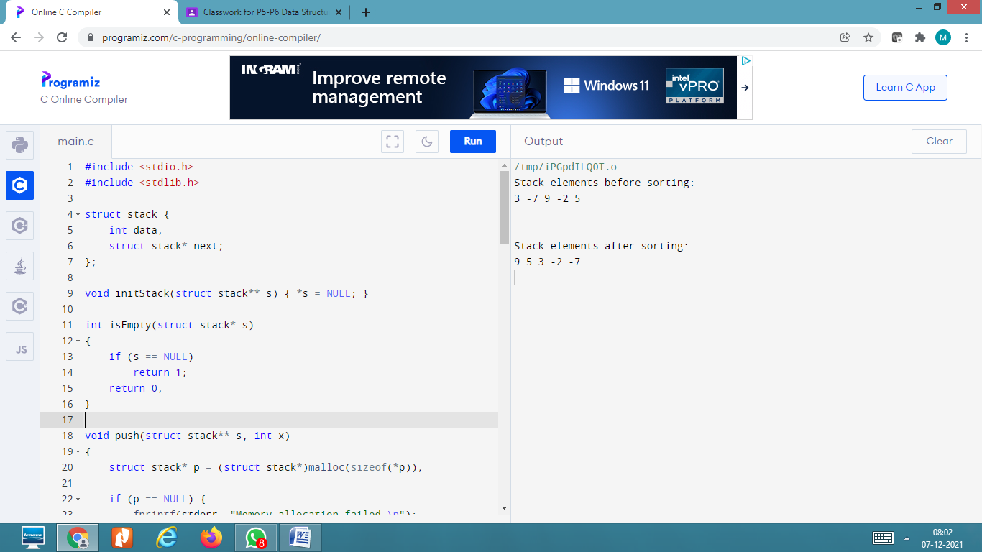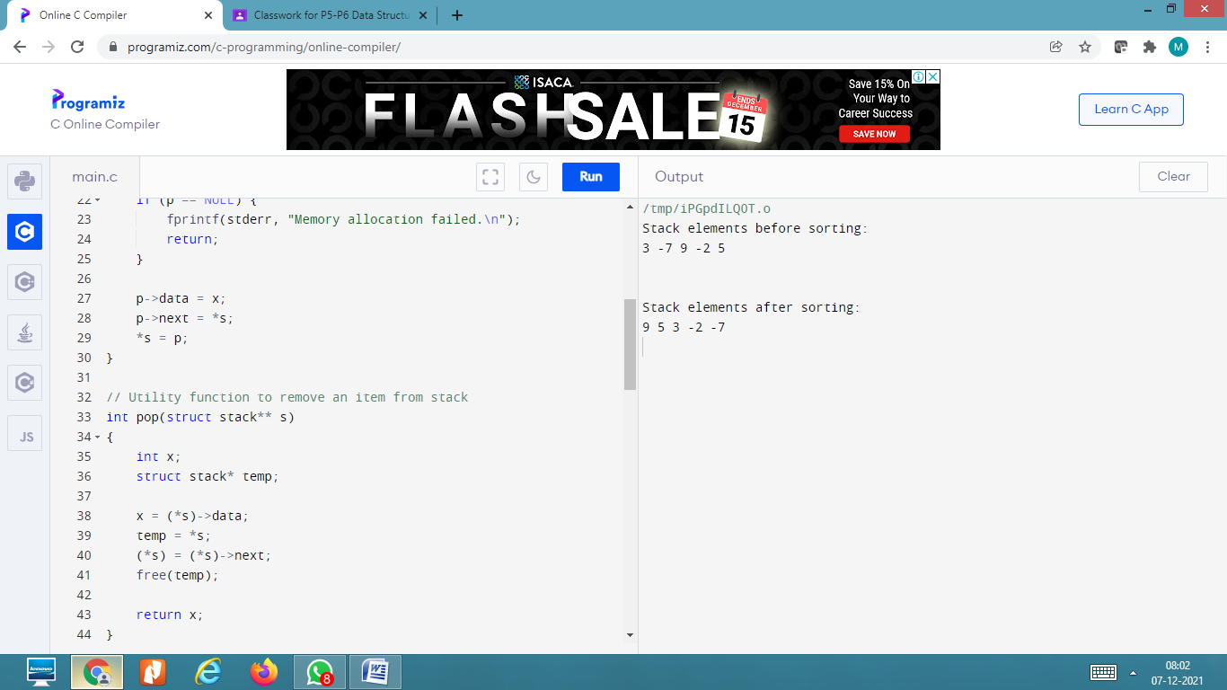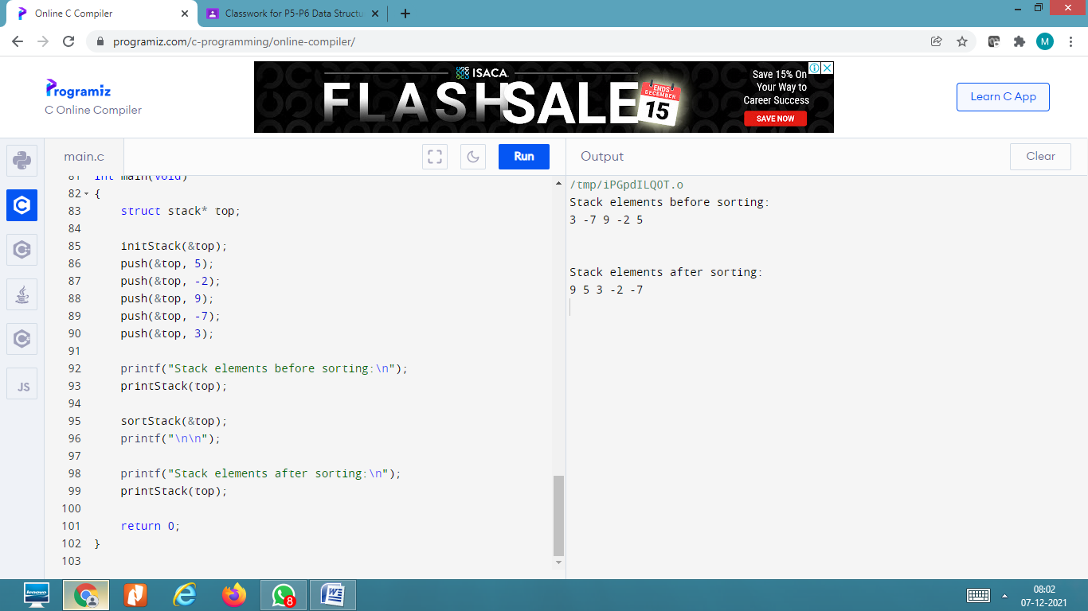

#include <stdio.h>

#include <stdlib.h>

#define bool int

struct sNode {

char data;

struct sNode* next;

};

void push(struct sNode** top_ref, int new_data);

int pop(struct sNode** top_ref);

bool isMatchingPair(char character1, char character2)

{

if (character1 == '(' && character2 == ')')

return 1;

else if (character1 == '{' && character2 == '}')

return 1;

else if (character1 == '[' && character2 == ']')

return 1;

else

return 0;

}

bool areBracketsBalanced(char exp[])

{

int i = 0;

struct sNode* stack = NULL;

while (exp[i])

{

if (exp[i] == '{' || exp[i] == '(' || exp[i] == '[')

push(&stack, exp[i]);

if (exp[i] == '}' || exp[i] == ')'

|| exp[i] == ']') {

if (stack == NULL)

return 0;

else if (!isMatchingPair(pop(&stack), exp[i]))

return 0;

}

i++;

}

if (stack == NULL)

return 1;

else

return 0;

}

// Driver code

int main()

{

char exp[100] = "{()}[]";

if (areBracketsBalanced(exp))

printf("true \n");

else

printf("false \n");

return 0;

}

void push(struct sNode** top_ref, int new_data)

{

struct sNode* new_node

= (struct sNode*)malloc(sizeof(struct sNode));

if (new_node == NULL) {

printf("Stack overflow n");

getchar();

exit(0);

}

new_node->data = new_data;

new_node->next = (*top_ref);

(*top_ref) = new_node;

}

int pop(struct sNode** top_ref)

{

char res;

struct sNode* top;

if (*top_ref == NULL) {

printf("Stack overflow n");

getchar();

exit(0);

}

else {

top = *top_ref;

res = top->data;

*top_ref = top->next;

free(top);

return res;

}

}

